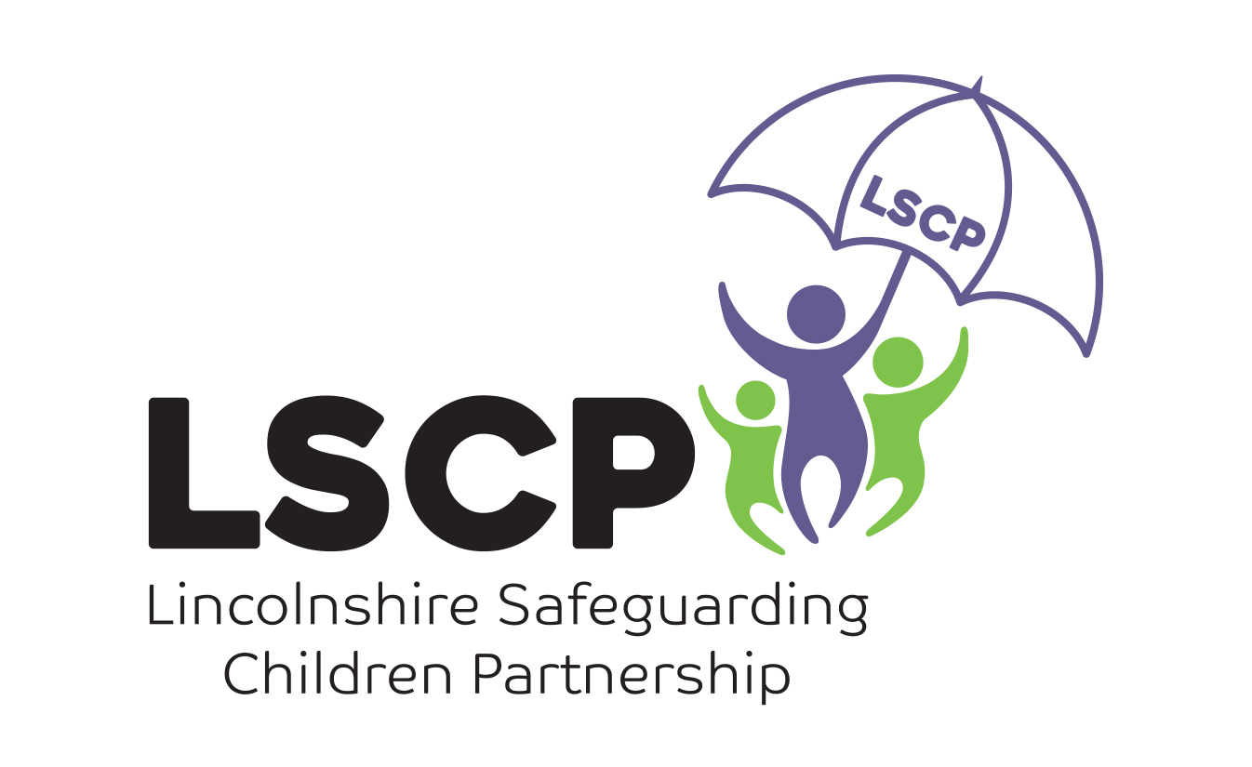 | CHILD PROTECTION CONFERENCES PROFESSIONALS’ BRIEFING SHEET

WHAT DO I NEED TO DO BEFORE THE CONFERENCE?
When you are invited to attend a Child Protection Conference, you will also need to provide a written report to the local authority two working days before an initial conference and five working days before a review conference.

Your report should be completed on the multi-agency template, a word version can be downloaded from the LSCP website, there is usually a template for your report attached to your invite too. Once completed your report should be emailed to:
SafeguardingandReview@lincolnshire.gov.uk

Our Lincolnshire Safeguarding Children's Partnership’s local procedures set out your responsibility to discuss the contents of your report with the person you are writing about. If this is a child, you should consider whether they are of sufficient age and understanding for you to share the report directly with them or whether you just need to share it with their parent or family member. It is important that children and their families are adequately prepared for the conference and the most important part of this preparation is you discussing your report with them and providing them with a copy of this before submitting the report to conference. It is important that reports are shared in a way that the parents / carers /young people are able to understand what you are saying about the worries and strengths in their lives. Ensuring you share information appropriately may involve you in securing a translation service or providing other suitable support as required.

WHAT SHOULD BE INCLUDED IN THE MULTI-AGENCY REPORT?
Professionals are expected to write their report based on their professional knowledge and understanding of the child and family. Each agency brings their own perspective. Whilst the analogy of a jigsaw in safeguarding is an old one, the CP conference is collaborative jigsaw building! A good conference will include all professionals and family members involved in a child’s life, and they will bring their pieces of information and fit the pieces together to build the most accurate picture possible of the child’s life. The output of the conference must be a comprehensive picture of risk and protective factors for each child in the family. Professionals and family members can then create a safety plan which is the roadmap to safety for the children.
Your report should address the following:

What are we worried about?
- What are the past and current dangers and risks for the child?
- What is placing the child at risk of immediate and significant harm?
- What has the child experienced? If you are supporting one of the adults in the family, think about how the adult might appear to the child, if they are experiencing difficulties themselves how might this impact on their parenting?
- Is there evidence that might indicate the child is being ill-treated or their health and development is being impaired?

Complicating factors
- Factors that contribute to, or cause difficulty to a child. This could be a parent’s mental health being exacerbated by alcohol, or information that requires additional information to reliably assess risk.

Existing Safety & Strengths (What’s working well)
- Things that are currently in place and that have been shown, over time, to directly address areas of risk and reduce danger for the child.
- Positive attributes and resources within the family that, over time, could be built on to provide a safer environment, e.g. a family member looking after children or a parent ceasing certain behaviour.

What Needs to Happen?
- What can you recommend the family can do themselves to create a safety plan
- How would you want to see them address the worries?
- You should make any recommendations for additional support that can be offered too.
- You should state in your report whether you feel a child protection plan will be needed.

It is acknowledged that as the conference takes place, and everyone’s information is shared, individual professionals may change their views based on hearing new information. This is why it is so important everyone prepares for the meeting and produces high quality evidence-based reports. It is essential that professionals and family alike are well informed about the worries of the children’s social worker, can bring their own professional perspective and can look at all the evidence to make a decision.

Setting out worries and what’s working well and providing professional analysis about the impact on the children in the household of the adult’s behaviour is a real gift to the children.

THE CONFERENCE

As part of your invite you will be notified of the when and where the conference will be taking place. Please ensure that you arrive in good time so that the meeting can start promptly. Please note: as standard there is no parking provided, therefore you will need to source your own parking for the duration of the meeting. Please also note that you will not be provided with a paper copy of the reports during the conference.
When you attend the meeting it is assumed that you will have read all of the reports you have been provided with. The chair will not be asking people to read from their reports. Each professional will be asked to succinctly provide key information focusing on:
- What they are worried about (dangers/risks – both current and past – for the child);
- Complicating factors;
- Family strengths;
- Safety factors.

It is important that all information is presented in everyday language that avoids professional jargon. Family members are given the opportunity to ask questions about the information shared. The chair will also ask family members additional relevant questions or seek clarity on certain issues as needed.

THE SAFETY PLAN
The safety plan will be discussed and considered throughout the meeting and any agreed outcomes and actions will be recorded at the time they are discussed. The conference the chair will ensure the conference is run in such a way that enables both professionals and the family to contribute to the safety plan and make it child specific and relevant for the whole family and their context. The safety plan is the route map from danger to safety. It should include specific actions, explain who will undertake them and how they will help the child or prevent something unwanted happening. Some items on the safety plan will be about contingency planning for when there is danger imminent, and other items will be about people or behaviours that can assist in securing long term safety for the children.

SAFETY SCALE
When all the necessary information has been shared and analysed, the chairperson will ask all agencies and family members to make a judgment about the safety of the child in their family home and the potential risk of future harm.

0  No Safety | 10  Safety

Family members and professionals will be expected to scale the level of safety for the child (or children) between 0-10, where 0 = ‘no safety’ and 10 = ‘safety’. Professionals will also be expected to provide a reason for their scaling and identify what would need to happen to move up the scale.

CRITERIA FOR MAKING A CHILD SUBJECT TO A CHILD PROTECTION PLAN
The conference is required to determine the risk and the likelihood of significant harm for the child/children in question. The chair will explain the threshold for a child protection plan and will ask each agency for their view about whether the outline Safety Plan developed in the conference constitutes a Child Protection Plan or if the needs of the child/children can be met through another type of plan. (Child in Need; Team Around The Child)

The tests for a child protection plan are that either:
- The child can be shown to have suffered ill-treatment or impairment of health or development as result of physical, emotional, or sexual abuse or neglect and professional judgement is that further ill-treatment or impairment are likely.
or
- Professional judgment, substantiated by the findings of enquiries in this individual case or by research evidence, is that the child is likely to suffer ill treatment, or the impairment of health or development as result of physical, emotional, or sexual abuse or neglect.

The chair will consider the views of all agencies and will then determine the final status of the plan. If the plan is confirmed as a Child Protection Plan the chair will ask agencies which category the child protection plan should be:

- Physical Abuse | - Emotional Abuse | - Sexual Abuse | - Neglect

